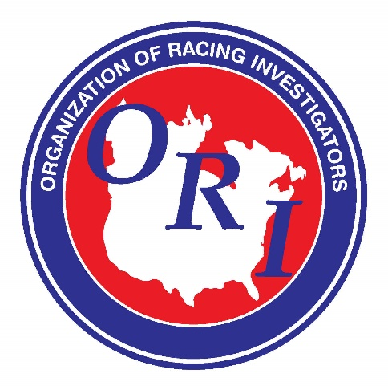
EVENT PRESS RELEASE

CONTACT INFORMATION:
Organization of Racing Investigators
Don Ahrens
dahrens@shrp.com
http://www.horseracinginvestigators.com/

FOR IMMEDIATE RELEASE

Headline: Organization of Racing Investigators Cancels the 2021 Annual Conference

Ozone Park, New York – The Organization of Racing Investigators (ORI) will cancel its annual conference, originally scheduled for March 2021, due to the COVID-19 pandemic.

Due to the cancellation, the ORI conference in 2022 will be held at Aqueduct Racetrack, located in Ozone Park, New York, with more details coming mid-2021.

Current 2020 ORI members will have their membership extended through calendar year 2021.

###

