Jean Claude Jaramillo Juan C. Estrada Chairman Vice-Chairman
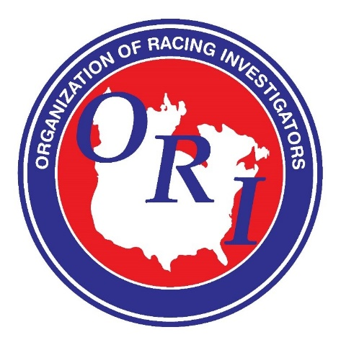
ORGANIZATION OF RACING INVESTIGATORS CONFERENCE
Aqueduct Racetrack: New York City: March 27th – 30th, 2022
Preliminary Agenda

- Keynote Speaker – Hon. Paul D. Tonko, United States Congressman, co-sponsor of the Horseracing Integrity and Safety Act.

- NYRA Security Operations – John Clyne, Senior Director, Security, New York Racing Association.

- Stewarding in New York State – Braulio Baeza Jr., State Steward, New York State Gaming Commission.

- Jockey Club Industry Initiatives – Kristin Werner, Senior Counsel, The Jockey Club.

- Pre-Race Joint Treatments in the RaceHorse – Dr. Scott Palmer, VMD, Equine Medical Director, New York State Gaming Commission.

- From the Finish Line to FedEx: Testing Sample Integrity – Leasa Johnson, Chief Investigator, New Mexico Racing Commission.

- Examples of Pool Manipulation and Grey/Illegal Market Betting – Patrick Cummings, Executive Director - Thoroughbred Idea Foundation.

- Corporate Protocols – Dr. Dionne Benson, DVM, JD, Chief Veterinary Officer, 1/ST Racing.

- **Media Training – Patrick McKenna, Vice President, Communications, New York Racing Association.

- **Interference Rules and Protocols: Consistency in Decisions – Braulio Baeza, (State Steward), Brook Hawkins (NYRA Steward), Dr. Jennifer Durenberger (Jockey Club Steward).

- **Understanding Microchips and Digital Certificates – Teena Appleby, Technician Operations & Investigations, Thoroughbred Racing Protective Bureau.

- **Racehorse Aftercare Awareness – Richard E. Schosberg, President of the Take2/Take The Lead Thoroughbred Retirement Program.

- **Concussion Protocols and Return to Ride – Patricia Morrison, Premise Health.

- ORI Membership Business Meeting.

* Speakers are subject to change.
** ROAP Points of Emphasis agenda item.

